API Development with Django REST Framework
Software Installation: Gitbash, Visual Studio code
What is an API?
- API stands for Application Programming Interface
- It acts as a two-way communication bridge between frontend and backend
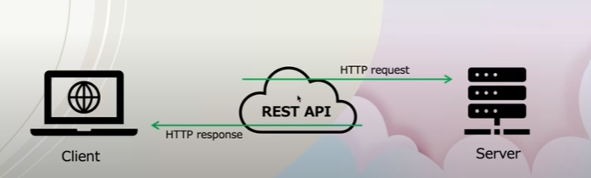

What is REST API?
- REST stands for Representational State Transfer
- It organizes how web applications talk to each other, separating what the user sees from what runs behinds the scenes
Principles:
- Stateless: The server doesn’t store any information about the client between requests
- Client -Server Architecture: The app(client ) asks for things(data) and the server does what is requested (send data or makes changes)
- Standardized interfaces: REST APIs reply on a set of standard methods(GET,POST,PUT,DELETE) for interacting with resources(data object)
GET – retrieving the resource
POST – creating the resource
PUT - updating the resource
DELETE - deleting the resource
- Easy-to-read Data: REST APIs returns the response in a standardized easy to read formats, typically JSON or XML formats
RESTFUL operations:
URI
GET /students
POST /students
PUT /student/1
DELETE /student/1
Meant for CRUD operations
Django installation:
Create a folder and open with vs code and open terminal.
Create virtual environment: python -m venv env
pipfreeze
For activation: source env/scripts/activate in git bash
Install Django: pip install Django
Pip upgrade: pip install -upgrade pip -> optional
Create a Django project: django-admin startproject django_rest_main .
To run server: python manage.py runserver
Django REST framework installation:
Django framework is a powerful and flexible toolkit for building Web APIs.
Simple Architecture(Django core project -web)
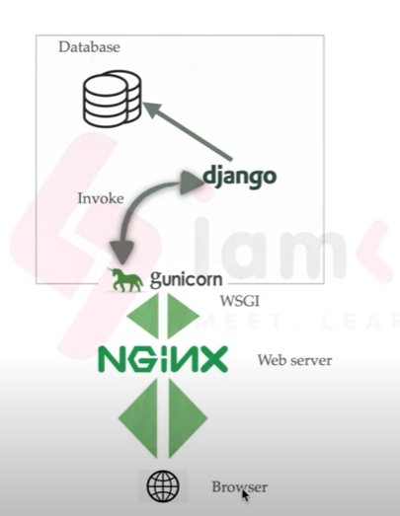
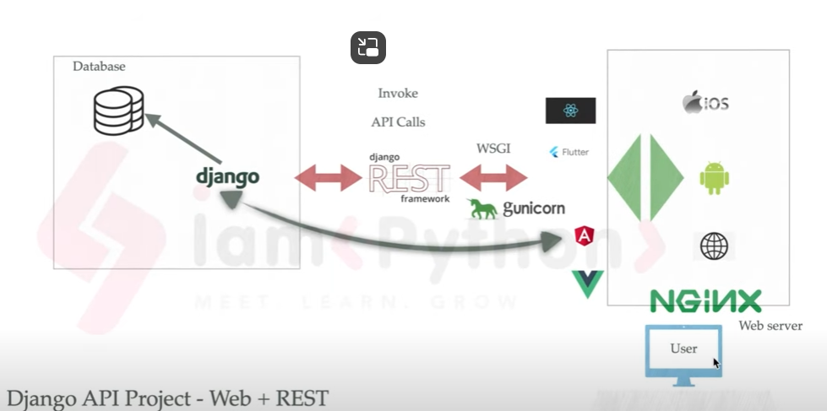
Why we need to learn Django REST framework?
- Web browsable API
- Restful web-services
- Authentication policies
- Serialization
Many companies like mozilla, RedHat, Heroku are built using Django REST framework.
API vs REST:
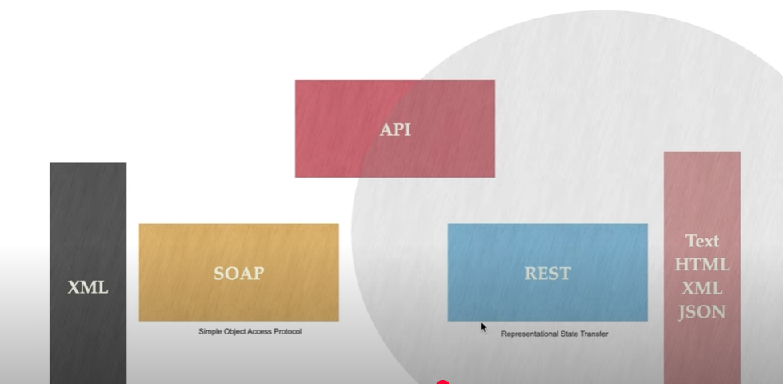
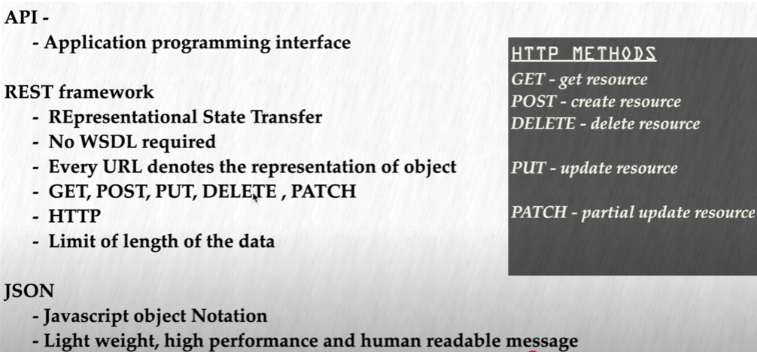

Go to: https://www.django-rest-framework.org/
Installation command: pip install djangorestframework
Add rest_framework to the settings.py
Type: python manage.py migrate
Create superuser: python manage.py createsuperuser
Web Application Endpoints:
Users can directly access it from the web browsers
http://127.0.0.1:8000/students/
create an application with name students: python manage.py startapp students
Add it in settings.py
Goto urls.py and type: #web application endpoint
path('students/', include('students.urls')),
later, create urls.py in students
import from django.urls import path from urls.py of Django_rest_main to students urls.py
go to views.py and define function:
def students(request):
students=[
{ 'id':1, 'name':'John Doe', 'age':20}
]
#return HttpResponse('<h2>Hello world</h2>')
return HttpResponse(students)
run server now

API endpoints:
Returns the data to integrate into the frontend
http://127.0.0.1:8000/api/v1/students/
create an application with name api: python manage.py startapp api
now Goto urls.py of Django_rest_main and type:
#API endpoints
path('api/v1/', include('api.urls'))
add api in settings.py
now create urls.py in api and add:
from django.urls import path
from . import views

urlpatterns = [

path('students/',views.studentsView,name='students'),
path('students/<int:pk>/',views.studentDetailView),
]
Goto views.py of api and add:
def studentsView(request):
students={
'id':1,
'name':'John Doe',
'class':'BCA',
}
return JSONResponse(students)

Create Model: Dynamic data from database
Python manage.py migrate
Register in admin.py of students
python manage.py createsuperuser
run: python manage.py runserver
create model in students of models.py as:
from django.db import models

# Create your models here.
class Student(models.Model):
student_id = models.CharField(max_length=10)
name = models.CharField(max_length=50)
branch = models.CharField(max_length=20)

def __str__(self):
return self.name
execute python manage.py makemigrations
execute python manage.py migrate
register in admin.py as:
from django.contrib import admin
from .models import Student
# Register your models here.

admin.site.register(Student)
now goto api of views.py to get the dynamic data
def studentsView(request):
students= Student.objects.all()
students_list=list(students.values())
return JsonResponse(students_list,safe=False)

Serializers:
- Serialization: It is used to convert complex model object or queryset into JSON format.
- Deserialization: It is used to convert JSON format into queryset or complex model object.
Function Based View GET method:
Create serializers.py in api
Goto views.py and update the GET code
Import; ->
from .Serializers import StudentSerializer
from rest_framework.response import Response
from rest_framework import status
goto -> http://127.0.0.1:8000/api/v1/students/ as well as postman with get check
Storing data using Serializer:
Update views.py with POST and add data in http://127.0.0.1:8000/api/v1/students/

Single Object Primary Key Based Operations:
Goto urls.py in api and update : path('students/<int:pk>/',views.studentDetailView),

Update operation on Student:
Delete the student:

